BN, Jan 2020

Project 5840: Custom WO Dashboard

Customer: Sharp Tooling

This project creates a custom WO Dashboard that is built on top of the project 4564.

Basically, the old project 4564 displays WOs with the next 10 WCs, and color Red if the WC is past due (prefixed with !) and Green with Font Strike Out if WC is closed (prefixed with #)

1. **Features:**

Within 5840 these features are added:

1/ Add columns showing Remaining Hours on each WC, rounded to the nearest whole number. Seq closed will not show remaining hours.

2/ Add a column showing the total remaining hours of the next 10 WCs.

3/ Add 10 WO User Fields. The title of the User Fields will be set at:

System *Support > Administration > Company Options (Advanced) > Manufacturing Table Maintenance > WO Header User Fields.*

4/ Add other columns:

* WO On Hold

* Sales Person

* WO Original Due Date

* +/- Seq: This is a column having inline button, when clicked will open: Shop Floor Control > Administration > Add/Delete Operation Closed Date, and the Job number will be saved to the clipboard so user can use it to paste to the screen. User must have security access assigned to this menu item for this to work.

5/ Add Issue, Wip To FG radio buttons at the top right of the dashboard. Correct functionality of the View and Edit radio buttons.

In general, these radio buttons will work as following:

|  |  |  |  |  |
| --- | --- | --- | --- | --- |
| **Screen\Radio** | **View** | **Edit** | **Issue** | **Wip To FG** |
| **Job clicked** | WO view (*) | WO Open | Issue Material | Wip To FG |
| **Suffix clicked** | WO view (*) | WO Open | Issue Material | Wip To FG |
| **Part clicked** | Supply and Demand View | Supply and Demand with Edit | Supply and Demand with Edit | Supply and Demand with Edit |
|  |  |  |  |  |

For (*) if user is granted access to the WO view with no Dollars, the program will open WO view with no Dollars.

User must be in security group EditWO for the Edit button enabled.

In general, user must be granted access to the menu item to open the screen from the dashboard.

6/ Add second tab Due & Past Due. Functionality of the grid will be the same as the All Jobs tab.

7/ Add CutOff with Date range applied to WO Due Date.

8/ WO Due Date coloring: Past Due -> Red, On Hold -> Gray

**B. Some screenshots:**

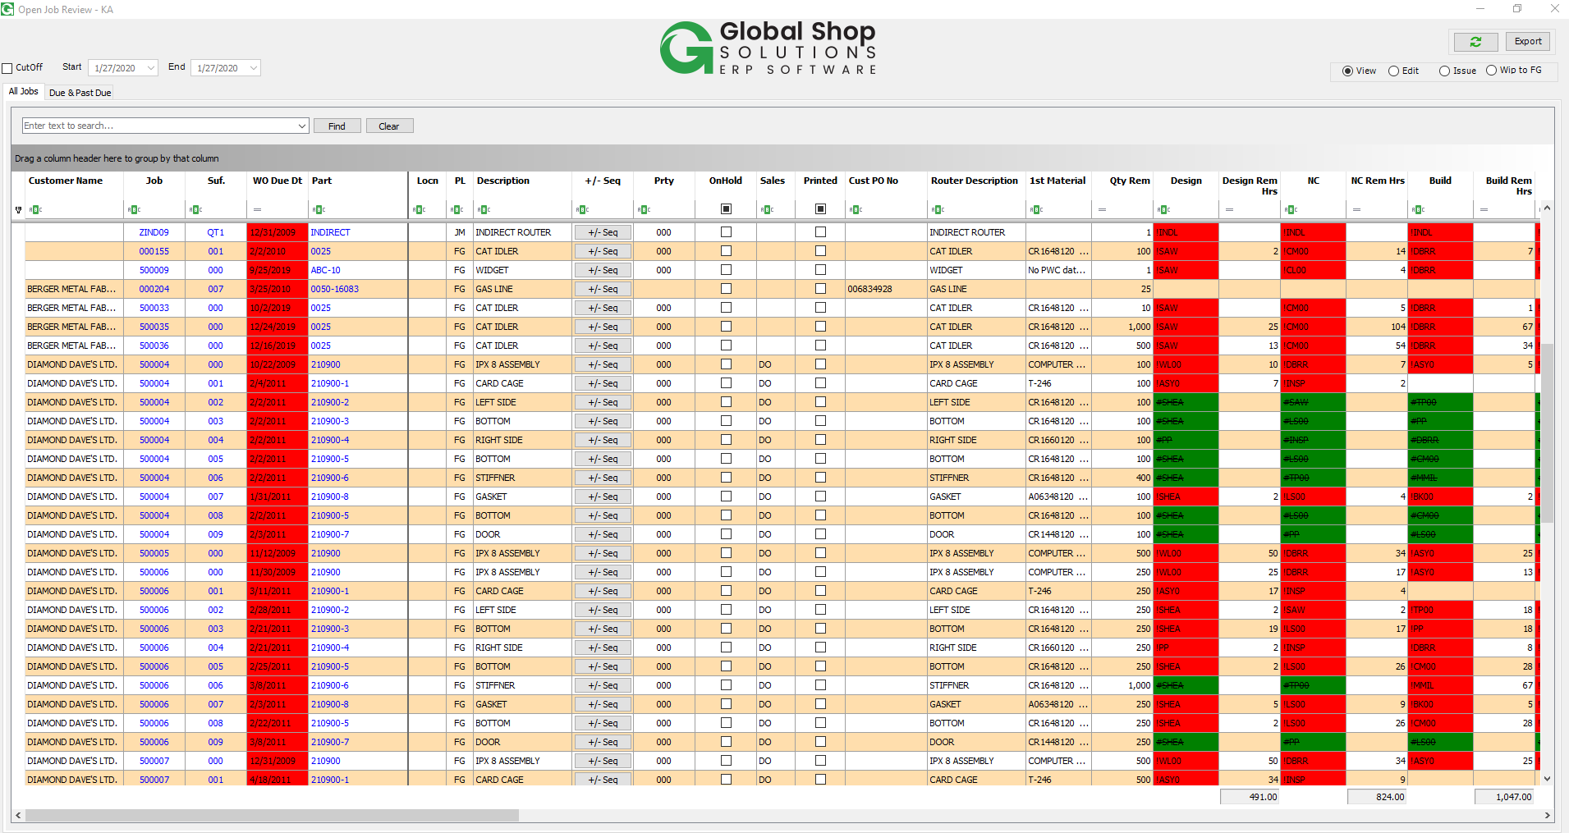

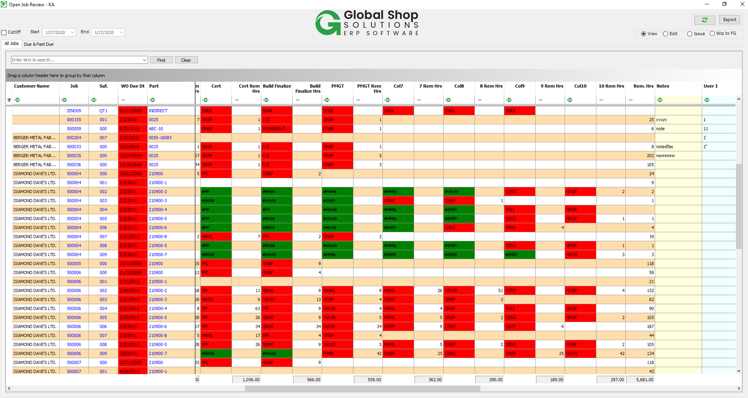

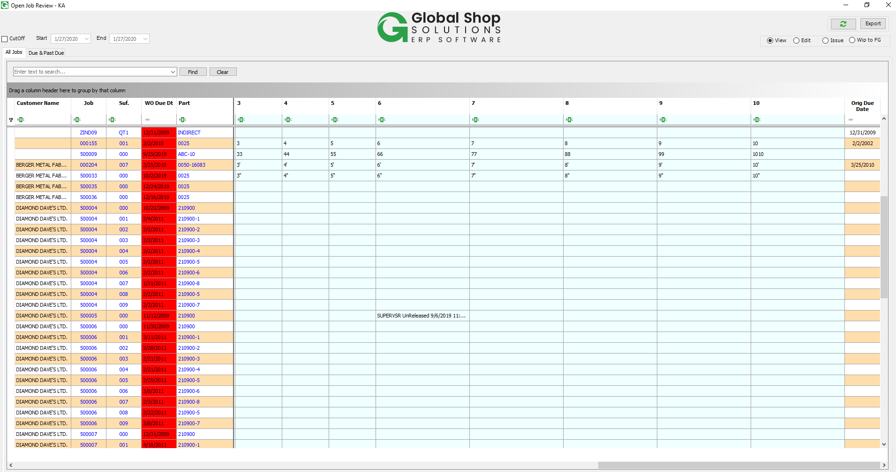

**More screenshots from customer:**

